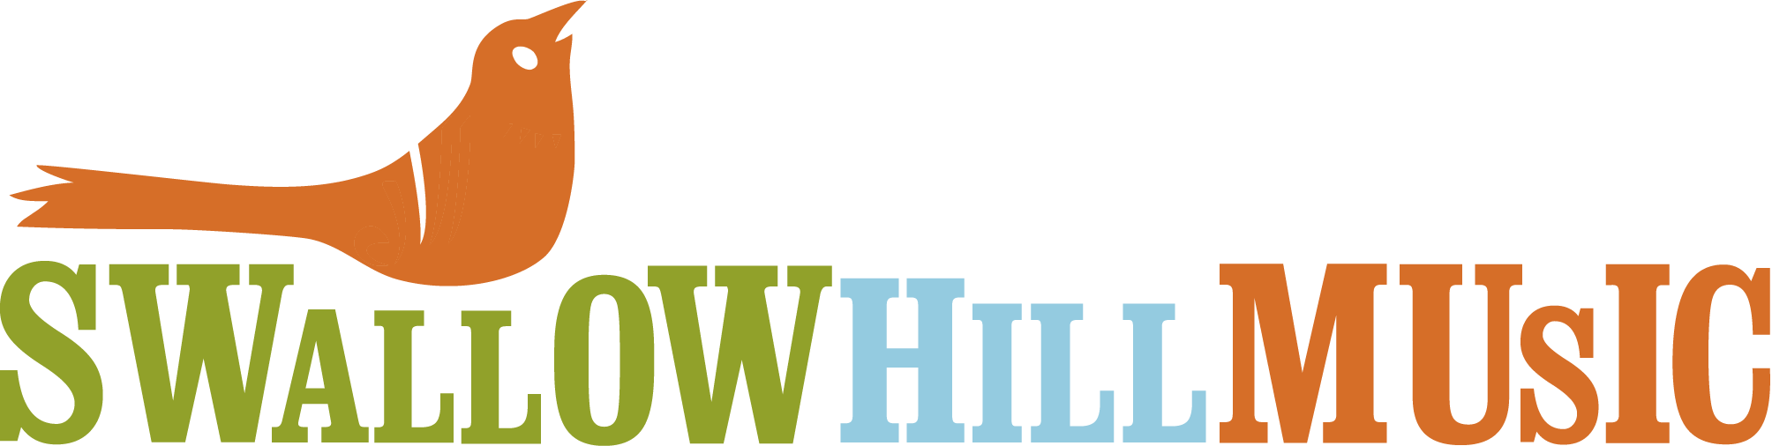

Hello and thank you for your interest in volunteering with Swallow Hill Music!

I am so pleased that you have chosen to dedicate your valuable time and energy to Swallow Hill Music. As a grass roots nonprofit organization, we depend heavily on volunteer staff to successfully execute our concerts and events, and assist in other areas such as administration, fundraising and building maintenance.

Founded in 1979, Swallow Hill Music is a nonprofit community for musicians and music lovers who appreciate the ability of music to bring people together. As a home for individuals and families who want to learn about, listen to and perform music, Swallow Hill Music enhances Colorado's cultural vitality and is a model for experiential music schools and performance spaces across the country. The organization serves more than 147,000 people through its school, outreach programming and concerts annually. Swallow Hill Music also presents and produces concerts at a wide range of venues across Denver. For more information visit www.swallowhillmusic.org.

Before you begin your volunteer duties, I would like to request that you complete the necessary forms. Once this information has been reviewed and you have completed a training and orientation session, we can select some dates and times for you to begin your volunteer experience!

Please don’t hesitate to contact me at corbin@swallowhillmusic.org if you have any questions. Thank you again for your interest in volunteering for Swallow Hill Music. I look forward to counting you among my colleagues here in the very near future.

Best,

Lindsay Corbin
Volunteer Coordinator

